Melinda Young - List of Work
Updated 29-5-2026
Terra Suburbia

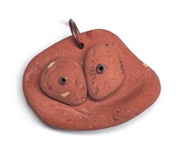 | Flowerpot face, 2026, Ocean tumbled terracotta flower pot and roofing tile fragments gathered on the beach, copper  $250
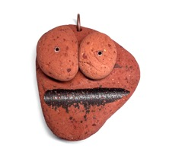 | Glazemouth, 2026, Ocean tumbled Marseilles pattern roofing tile fragments gathered on the beach, copper  $350
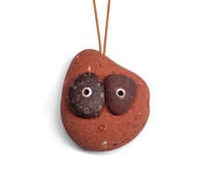 | Pebble eyes, 2026, Ocean tumbled roofing tile fragment and pebbles gathered on the beach, copper, paracord  $350
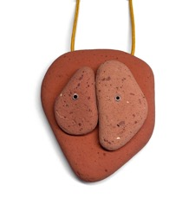 | Tile eyes, 2026, Ocean tumbled Marseilles pattern roofing tile fragments gathered on the beach, copper, paracord  NFS
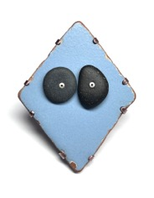 | Blue diamond (Convertible brooch/pendant), 2026, Ocean tumbled house tile fragment and pebbles gathered on the beach, patinated copper, 925 silver  $650
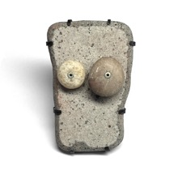 | White Oblong (Convertible brooch/pendant), 2026, Ocean tumbled house tile fragment and pebbles gathered on the beach, patinated copper, 925 silver  $550
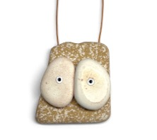 | Yellow Speckle, 2026, Ocean tumbled house tile fragments gathered on the beach, aluminium, paracord  $200
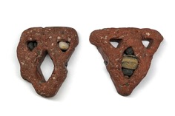 | The Unwelcome Guests, 2025, Bulli lattice brick fragments, pebbles lodged in place by the ocean, patinated copper, oxidised 925 silver.  $650 each
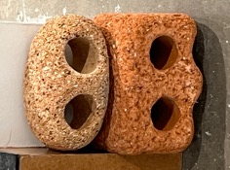 | 4-eyed Sentry, 2025, Ocean tumbled house bricks gathered on the beach  $250
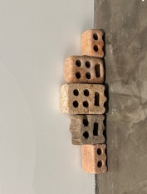 | Sentries, 2025, Ocean tumbled house bricks gathered on the beach  POA
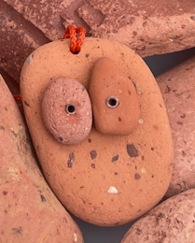 | Baby tile eyes, 2026, Ocean tumbled Marseilles pattern roofing tile fragments gathered on the beach, copper, paracord  NFS
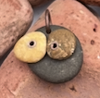 | Wonky pebble eyes, 2025, Pebbles gathered on the beach, copper
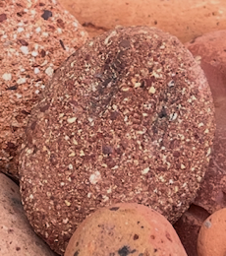 | Ghost eyes, 2025, Ocean tumbled brick fragment gathered on the beach, waxed cotton, coal pigment  $250
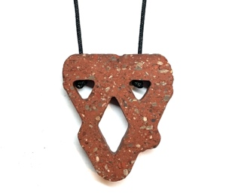 | The Unwelcome Guest Pendant, 2025, Bulli lattice brick fragment, linen cord.  $250

